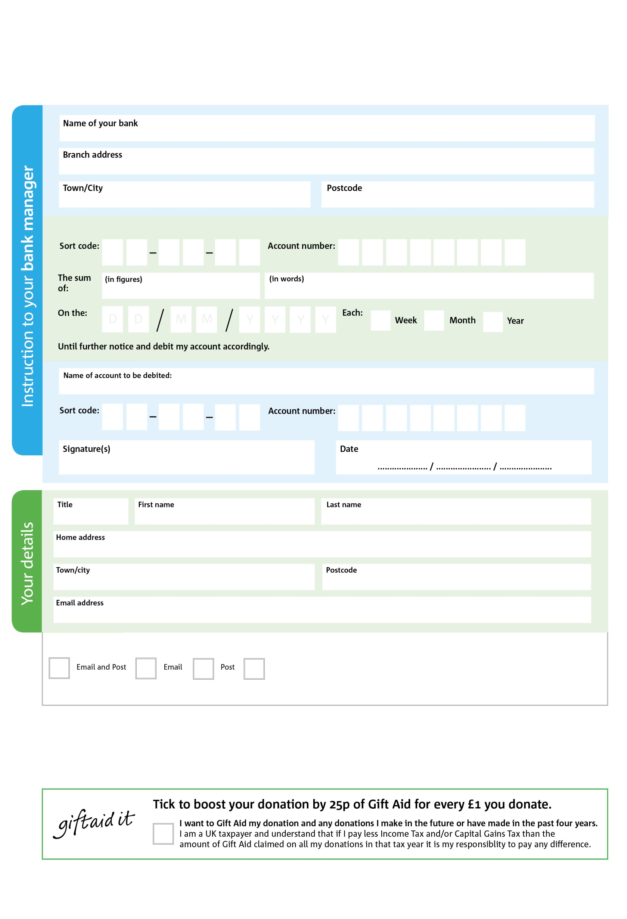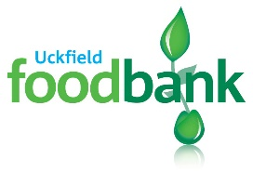

Reg. Charity No: 1153505 | Reg. in England & Wales May 2018

POSTAL ADDRESS: Uckfield Foodbank, 15 Horsted Square, Bellbrook Industral Estate, Uckfield, TN22 1QG

6

V

8

V

9

V

0

V

6

V

1

V

3X

V

6

V

**Please pass this form onto the foodbank, using the foodbank’s address at the bottom, who will save a copy for their records.   
They will then send it onto your named bank or building society.**

5

0

2

2

0

6

We would love to keep you up to date with information about Uckfield Foodbank. Please tick your preference:

You can change your preferences any time by contacting us on 01825 745489 or emailing us at admin@uckfield.foodbank.org.uk

I do not wish to receive future communications from Uckfield Foodbank

Please pay Uckfield Foodbank,

**Data protection**

*'Uckfield Foodbank is committed to protecting your privacy and will process your personal data in accordance with current Data Protection legislation. Uckfield Foodbank collects information to keep in touch with you and supply you with information relating to our work. To unsubscribe from our newsletter, send a message to the email address above with the word unsubscribe in the subject line. A full data privacy statement for financial donors is available from the foodbank on request.’*

**Standing Order Mandate**

**Uckfield.foodbank.org.uk**

You can change your preferences any time by contacting us on XXXXXXXXXXX or emailing us at XXXX@XXXXXXXXXX.foodbank.org.uk

I do not wish to receive future communications from XXXXXX Foodbank